SPACE ROBOTICS

# INTRODUCTION

Space robotics is the development of general purpose machines that are capable of surviving in the space environment, performing exploration , construction, maintenance, servicing or other tasks. Humans control space robots from either a “local” control console or “remotely” controlled from human operators on Earth. Space robots are generally designed to do multiple tasks.

## SPACE RESEARCH

“SPACE”, the word itself signifies something infinite. Space travel has always been dangerous and any unexpected event can cause death. It is here that the robots play a huge role and help mankind in his research process.

## HOW ROBOTS WORK IN SPACE?

Working principle of Space robots are based on the SPA algorithm. SPA stands for sense, plan and action. It is used in built world modules to match and worked accordingly.

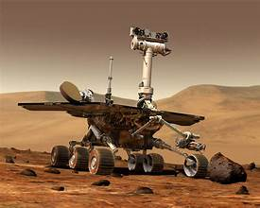

## FLOWCHART

Technologies Used: Mapping and navigation One of the basic functions of a space robot is to navigate its way cleverly through all obstacles that come in its way. Mapping and navigation comprise of three more technologies.

1.Obstacle avoidance 2.Mapping 3.Path planning 4.Planning: It is a feature by which a robot understands the situation and 5.decides a strategy to tackle it. 6.Sequencing: Selection of a particular skill set which would result in perfect execution of a plan. 7.Control: Performing the selected skill set to perfection.

## TYPES OF SPACE ROBOTS:

1.PLANETARY ROVERS:

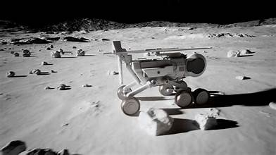

It is the most advanced form of robotics technology used in space research. They are the robots, which explore, navigate and research themselves with the least human intervention; they analyze the data collected and send the results back to earth.

## 2.IN-ORBIT OPERATORS:

They are the robots, which assist an astronaut during his space mission. For example a robot can be designed specially to refuel a shuttle thus helping the astronaut to remain in his shuttle and accomplish various tasks without any risk to their lives.

## 3.PROBES:

A similar class of robots explores the system without actually physically landing anywhere. These typically use cameras and variety of instruments to measure other planets, moons, and the sun from distance. Most of these use solar cells to their instruments.

**4.ASTRONUT ASSISTANCE**:

Besides acting as explorers, space robots can also assist astronauts in manned spaceflight. One of the most notable a device known as the Canadarm. with funding from the Canadian Space the Canadarm became a permanent fixture many American space shuttles and the international space station.

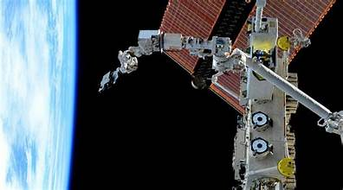

CONCLUSION:

In conclusion, space robotics is a rapidly advancing field that's transforming our understanding of the universe and our place within it. From planetary exploration to satellite maintenance, robots are playing an increasingly crucial role in space missions. As we continue to push the boundaries of space travel and discovery, robots will be essential companions, enabling us to venture further, explore more efficiently, and uncover new secrets of the cosmos.

# REFERENCES:

[https://www.nasa.gov/audie nce/](https://www.nasa.gov/audie%20nce/) for educators /robotics/ home/ https://www.learnaboutrob ots.com/ space.htm

https://en.wikipedia.org/wiki/Robotis_spacecraft

https://www.google.com/imghp